

**SOFTWARE ENGINEERING ASSIGNMENT**

* What is software ? what is software engineering ?

**SOFTWARE** is a set of computer programs and associated with documentation and data . This is in contrast to hardware , from which the system is built and which and actually performs the work.

**SOFTWARE ENGINEERING** is a systematic engineering approach to software development.

A software engineer is a person who applies the principle of software engineering to design , develop, maintain , test and evaluate computer software.

* Explain types of software.

There are total 5 types of software

* Application software
* System software
* Driver software
* Middleware
* Programming software

Let’s study all of them in detail

**APPLICATION SOFTWARE**

This is the most common type of software, application software is a computer software package that performs a specific function for the user , or in some cases , for another application.

**SYSTEM SOFTWARE**

These software programs are designed to run a computer’s application programs and hardware. It coordinates the activities and functions of hardware and software.

**DRIVER SOFTWARE**

It is also known as device drivers, this software is often considered a type of system software . Device drivers control the devices and peripherals connected to computer enabling them to perform their specific tasks.

**MIDDLEWARE**

The term middleware describe software that meditates between application and system software or between two different types of application software . For example : Middleware enables Microsoft windows to talk to excel and word.

**PROGRAMMING SOFTWARE**

Computer programmers use programming software to write code. Programming software and programming tools enable developers to develop , write, test and debug other software programs.

* What is SDLC ? Explain each phase of SDLC.

The software development cycle (SDLC) refers to methodology with clearly defined process for creating high quality software.

The methodology focuses on the following phases of software development :

1.Requirement gathering

2. Analysis

3. Designing

4. Implementation

5. Testing

6. Maintenance

* What is DFD? Create DFD diagram on flipkart

A Data Flow Diagram (DFD) is a way of representing a flow of data through a process or a system. The DFD also provides information about the outputs and inputs if each entity and the process itself .

Here’s DFD diagram on flipkart.

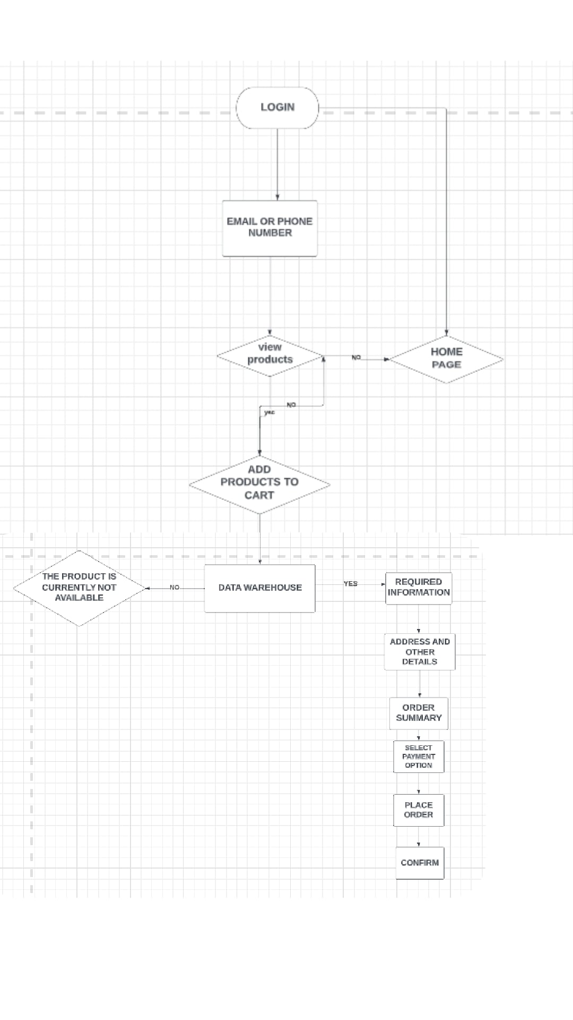

* What is flowchart ? Create a flowchart to make addition of two numbers .

A flowchart is a type of diagram that represents a workflow or process . A flowchart can also be defined as a diagrammatic representation of an algorithm, a step by step approach of solving task.

Here’s a flowchart to make addition of two numbers

